LAB 1 ASSIGNMENT
UNSTRUCTURED DATABASE LAB
RITTIKA ROY (UG/02/BTCSECSF/2023/025)

Q1. Create a database named collegeDB and switch to it.

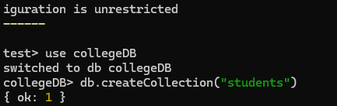

Q2. Create a collection named students in the collegeDB database.

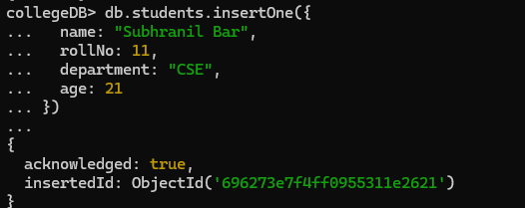

Q3. Insert one document into the student collection with the following fields: • name • rollNo • department • age



Q4. Insert four more documents into the student collection with different values.

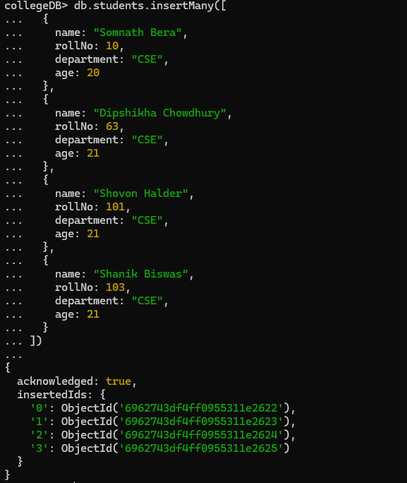

Q5. Display all documents present in the student collection.

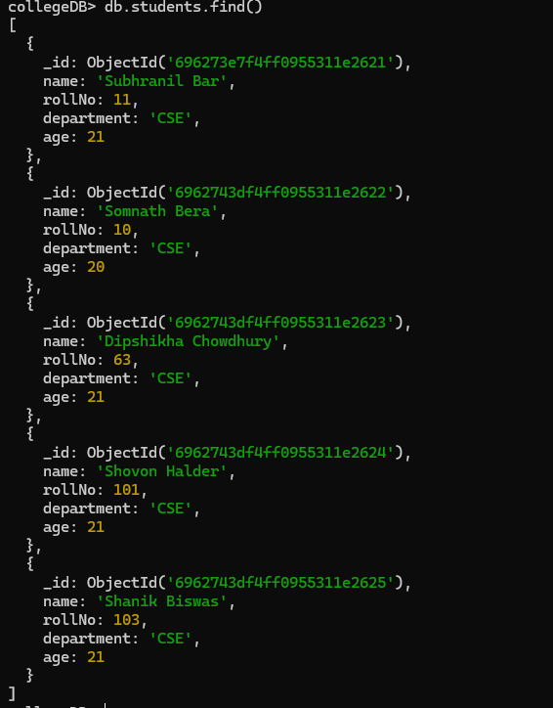

Q6. Display only those students who belong to the CSE department.

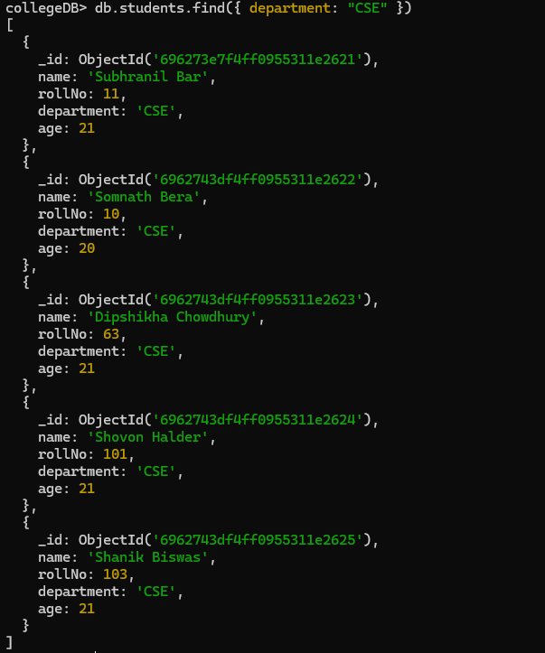

Q7. Update the age of one student (any one) to a new value

. 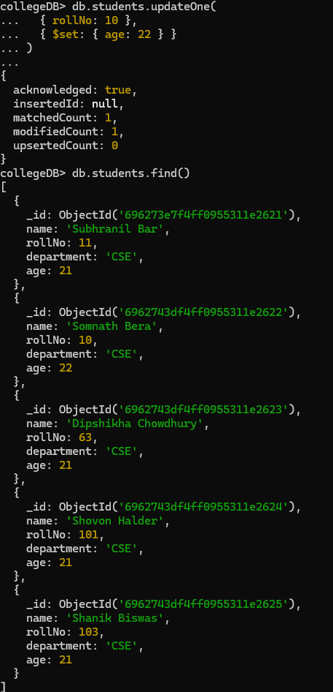

Q8. Delete one document from the student collection using any condition.

